SWST 31032 - APPLIED INFORMATION SYSTEMS
FACULTY OF COMPUTING AND TECHNOLOGY
UNIVERSITY OF KELANIYA
SRI LANKA

PROJECT REPORT
ON

TutorLink
A University Platform for Effective Student–Tutor Connections

Submitted by:
TISHANY.T
CT/2021/088
24thDecember2025

2.Abstract
TutorLink is a web-based platform created to make communication between university students and tutors simple and well-organized. Many students find it difficult to locate a suitable tutor within their own university, especially someone who teaches the correct subject and speaks their preferred language. Traditional methods like social media groups or messaging apps are unorganized, slow, and easily lead to misunderstandings. TutorLink solves these problems by providing one clear and easy to use system where students can sign up, log in, view available tutors, send tutoring requests, send feedback and track the status of each request.

In this system, tutors do not sign up by themselves. Their accounts are already created for them, ensuring that all tutors are verified university students. Tutors can log in, check student requests, accept or reject them, schedule meeting time, and provide student common notices. The platform also includes useful features such as meeting reminders and a feedback system, which help students express their learning experience and help tutors improve their support.

TutorLink is built using HTML, CSS, JavaScript, Firebase Authentication, and Cloud Firestore. These tools help maintain secure login, store user information safely, and update data in real time. The system is designed to be simple, user-friendly, and helpful for daily academic needs. In the future, TutorLink can be improved by adding features such as a tutor rating system, admin panel, a chat system for direct communication, and advanced search tools. These upgrades will make the platform even more effective for both students and tutors.

Table of Contents Page No
1. Title Page………………………………………………………………………………………………………….1
2. Abstract…………………………………………………………………………………………………………….2
3. Table of Contents………………………………………………………………………………………………3
4. Introduction………………………………………………………………………………………………………4
4.1 Problem Statement……………………………………………………………………………………..4
4.2 Objectives……………………………………………………………………………………………………4
4.3 Scope of the Project…………………………………………………………………………………….4
4.4 Significance of the Study………………………………………………………………………………4
5. Literature Review………………………………………………………………………………………………5
6. Methodology…………………………………………………………………………………………………….6
6.1 Approach / Methods……………………………………………………………………………………6
6.2 Data Collection…………………………………………………………………………………………….6
6.3 System Design……………………………………………………………………………………………..7
6.4 Detailed Steps of System Workflow……………………………………………………………..8
7. Results and Discussion………………………………………………………………………………………10
7.1 Findings……………………………………………………………………………………………………….10
7.2 Interpretation………………………………………………………………………………………………10
7.3 Challenges……………………………………………………………………………………………………11
8. Conclusion………………………………………………………………………….................................12
9. References…………………………………………………………………………………………………………12

4. Introduction
  - Problem Statement
- Many university students find it difficult to locate a suitable tutor who studies at the same university and can teach a subject in the student’s preferred language. Students often rely on social media groups or messaging apps, which are unorganized and lead to delays, missed messages, and confusion. Tutors also receive requests from many places, making it hard to manage their schedules properly. There is no single platform that allows students to view available tutors, send requests, or track updates in an organized way. A simple and reliable web-based system is needed to improve student–tutor communication.

4.2 Objectives
- Provide students with an easy method to find suitable tutors from the same university.
- Create a simple and organized online platform for student–tutor communication.
- Ensure secure login and signup using Firebase for students and tutors.
- Allow students to send tutoring requests, check request status, and receive meeting reminders.
- Support tutors in managing requests, scheduling sessions, and receiving
student feedback.

4.3 Scope of the Project
- This project focuses on developing a web-based platform for university students and tutors. The system includes student signup, student login, and tutor login using accounts already added to the database. Students can view tutors, submit requests, follow request progress, receive reminders, and give feedback. Tutors can view incoming student requests, accept or reject them, schedule meetings, and receive notifications. The system uses Firebase Authentication and Firestore Database for secure login and real-time data storage. Advanced features such as a chat system, rating system, or admin panel are outside the current scope but may be included in future versions.

4.4 Significance of the Study
- TutorLink provides an organized way for students to find academic support from tutors at the same university. It reduces confusion, saves time, and allows students to learn in their preferred language. Tutors benefit from a clear platform to handle requests and schedule sessions efficiently. The system improves communication, supports better learning outcomes, and creates a more helpful academic environment. TutorLink also forms a strong base for future improvements such as chat, rating, and advanced search options.
5. Literature Review
University students often seek extra academic support when they face difficulties in understanding course materials, preparing for exams, or completing assignments. Many students try to find tutors through social media platforms such as Facebook groups, WhatsApp chats, and Telegram channels. While these platforms are commonly used, they are not designed for educational support. Messages can get lost, responses may be delayed, and there is no proper way to manage tutoring requests. As a result, communication becomes unorganized and unreliable.
Some universities use Learning Management Systems (LMS) such as Moodle, Google Classroom, and Blackboard. These systems help lecturers share notes, assignments, and announcements, but they do not provide tools for peer tutoring or one-on-one student–tutor communication. They also lack features like request tracking, meeting reminders, or preferred language matching, which are essential for an effective tutoring platform.
Existing online tutoring platforms such as TutorMe, Wyzant, or Chegg Tutors offer professional tutoring services, but they are mostly paid services and are not designed for internal university use. These platforms do not allow students to filter tutors from the same university or request help based on campus-specific subjects. They also require complex sign-up processes and sometimes charge high fees, making them unsuitable for free peer-to-peer tutoring inside universities.
Many universities peer-tutoring systems still operate manually. Students contact tutors through printed posters, student union notices, or by asking friends. Tutors receive messages from different channels, making it hard to organize their schedule. This manual process also lacks features like automatic notifications, feedback collection, or secure data storage. Important information can be forgotten, misunderstood, or lost.
TutorLink is designed to solve these problems by providing a simple and organized web-based system that connects students and tutors from the same university. Unlike general communication tools, TutorLink supports structured request management, preferred language selection, scheduling functions, and feedback collection. It also uses Firebase Authentication and Firestore Database, which offer secure login, real-time updates, and safe data storage. These features make TutorLink more suitable and reliable for university-level tutoring.
From the review of existing tools and methods, no single system offers all the essential features needed for effective student–tutor interaction inside a university. TutorLink combines the strengths of modern web technologies and adapts them to create a focused academic support system that is easy to use and meets the needs of both students and tutors.
6. Methodology
  - Approach / Methods
- The TutorLink system was developed using a combination of modern web technologies:
- Frontend
HTML, CSS, and JavaScript were used to build an interactive and user-friendly interface.
Basic responsive design was applied to ensure the system works on different screen sizes.

- Backend Services
Firebase Authentication was used to manage secure student and tutor login functionalities.
Firebase Firestore was used as the main database to store student details, tutor information, tutoring requests, and session feedback.

- System Logic
JavaScript connected the frontend pages with Firebase, handled real-time updates, processed user actions (such as sending requests), and managed dashboard functions for both students and tutors.

  - Data Collection
- Data used in TutorLink was collected directly from users through the system’s web forms:
- Student collection Data
Collected during signup including name, email, course, year, and preferred language.

- Tutor collection Data
Pre-stored in the Firestore database, including tutor name, email, subjects, availability, and teaching languages.

- Tutoring Requests collection Data
Students submitted request details such as subject, language preference, description, meeting type, and tutor email.

- Feedback collection Data
After a session, students submitted a comment through the feedback.

6.3 System Design
- Database structure
The Firestore database contains four main collections:
    - Students collection
Stores student information (name, email, course, year, languages)

    - Tutors collection
Stores tutor information (name, email, subjects, availability, languages)

    - Requests collection
Stores all student–tutor request details(subject, language, meetingType, tutor email, topic/ problem description)

    - Feedback collection
Stores feedback submitted after tutoring sessions (Tutor email, subject, date of sessions, comments/feedback)

- System Flow
- A student signs up and logs into the system using Firebase Authentication.
- The student browses available tutors based on language.
- A student sends a tutoring request by submitting a request form.
- The tutor logs in and views all incoming requests on the dashboard.
- The tutor accepts or rejects the request and may schedule a meeting time.
- The student receives a status update and meeting details.
- After the session, the student submits feedback into the system.

- Use Case Diagram
I have drawn the use case diagram showing the interactions between students, tutors and system.
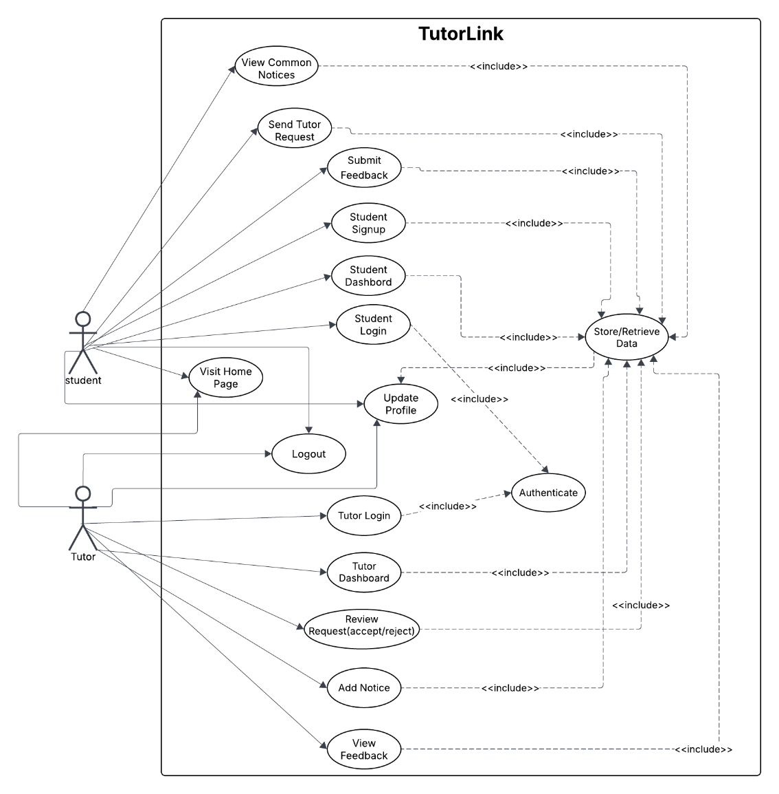

6.4 Detailed Steps of System Development
- User Registration/Login
- Student signup and login handled using Firebase Authentication.
- Tutor login allowed only through pre-created accounts stored in Firestore.
- Role-based access ensured that students and tutors view their correct dashboards.

- Managing Tutoring Requests
- Students enter request details using a web form.
- Data is stored in the requests collection in Firestore.
- Tutors view requests in real time through their dashboard.
- Tutors accept or reject requests and schedule meeting times.

- System Operations
- Display available tutors filtered by subject or language.
- Update request status instantly after tutor action.
- Load meeting details, reminders, and notifications from Firestore.
- Display request progress in both dashboards.

- Feedback Handling
- Students submit feedback after each session.
- Feedback is stored in the feedback collection.
- Tutors can view feedback for performance improvement.

- User Interface
- Pages designed using clean HTML and CSS for readability.
- Layout kept simple to support both students and tutors.
- Real-time data display achieved through JavaScript and Firebase listeners.

7. Results and Discussion
7.1 Findings
- The student signup and login functions worked correctly using Firebase Authentication.
- Tutor login using pre-created accounts worked without errors.
- Students could view tutors, send requests, and track request status.
- Tutors could see all incoming requests and accept or reject them.
- Real-time updates from Firestore showed status changes instantly.
- Meeting scheduling information appeared correctly in student dashboards.
- Feedback submitted by students was stored in the feedback collection.
- Notifications and reminders worked as expected.

7.2 Interpretation
- The results show that TutorLink improves communication between students and tutors.
- Real-time updates made the system faster and more reliable than social media or messaging apps.
- Students were able to find tutors based on subject and language preferences.
- Tutors benefited from having all requests displayed clearly in one dashboard.
- The system met its main goals of organizing academic support and reducing confusion.
- Firebase proved to be a suitable choice for security, data storage, and real-time synchronization.

7.3 Challenges
- Connecting different pages (login, requests, dashboards) to Firestore required careful coding.
- Handling separate roles for students and tutors caused some access-control issues.
- Displaying real-time updates on dashboards sometimes failed during early testing.
- Designing simple dashboards for two user types (student and tutor) took extra time.
- Setting up notifications and reminders needed multiple tests to function correctly.
- All these challenges were solved through debugging and revising the database structure.

8. Conclusion
The TutorLink system was developed to solve the common communication problems faced by university students when searching for suitable tutors. Before this system, students mainly relied on social media or messaging apps, which often caused delays, confusion, and unorganized communication. TutorLink provides a clear, structured, and reliable platform that helps students interact with tutors in a more organized way.
The system successfully allows students to sign up, log in, view tutors, send requests, track request status, receive reminders, and submit feedback. Tutors can log in using their pre-created accounts, manage student requests, accept or reject sessions, and schedule meeting times. All information is stored securely in Firebase Firestore, and real-time updates ensure fast and smooth communication.
The results of the project show that TutorLink meets its main objectives by offering a simple and user-friendly solution for student–tutor interaction. Although challenges were faced with Firebase integration, dashboard design, and real-time updates, these issues were solved through testing and improvements. The final system works effectively and can be expanded in the future with features such as a chat system, rating system, and improved search filters.
TutorLink provides a strong foundation for organizing peer tutoring within the university and has the potential to become a valuable academic support tool for students and tutors.

9. References (IEEE – Website Sources)
[1] Google Firebase, “Firebase Authentication,” 2025. [Online]. Available: https://firebase.google.com/docs/auth
[2] Google Firebase, “Cloud Firestore,” 2025. [Online]. Available: https://firebase.google.com/docs/firestore
[3] W3Schools, “JavaScript Tutorial,” 2025. [Online]. Available: https://www.w3schools.com/js
[4] W3Schools, “HTML Tutorial,” 2025. [Online]. Available: https://www.w3schools.com/html
[5] Mozilla Developer Network, “CSS: Cascading Style Sheets,” 2024. [Online]. Available: https://developer.mozilla.org/en-US/docs/Web/CSS
[6] Google Developers, “Firebase Security Rules Overview,” 2025. [Online]. Available: https://firebase.google.com/docs/rules

